Introduction

RS-485 connector shall have the following layout.
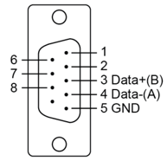
Figure 1: D-Sub 9 pin configuration
There shall be a jumper (0.1” 2 pins) to apply RS-485 bus termination. Termination resistors shall be on each board.
50 bps to 921,6 kbps baud rate must be supported.

Connector selection
L717TSEH09POL2RM8 was selected mainly for the quality of 3D model supplier had.

IC selection
SN65HVD12DR was selected for it’s price and availability. Same form factor and pin configuration alternatives exist with different data rates and temperature ranges. Alternatives exist from other manufacturers as well. For example, LTC1480IS8#PBF.

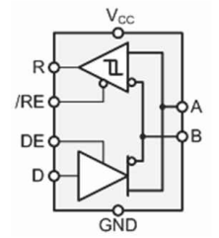
Figure 2: Simplified functional diagram of SN65HVD12DR

Circuit design
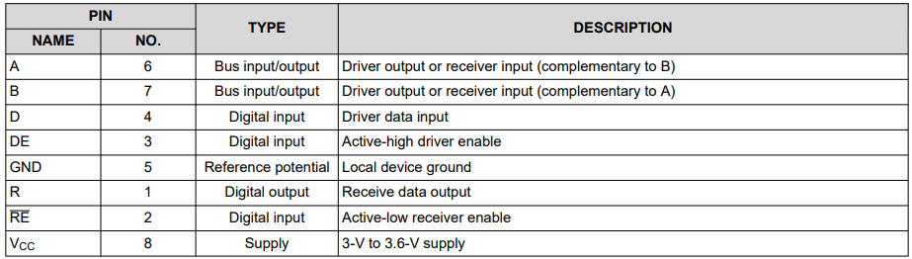
Figure 3: SN65HVD12DR pin description

Supply voltage range for the device is 3 to 3,6V. The maximum supply current for the device is 15,5 mA. With maximum receiver and transceiver output currents the total is 83,5 mA.

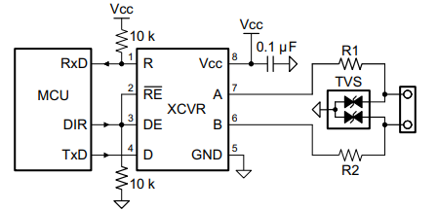
Figure 4: Typical application schematic

120Ω termination resistor will be added with the option of enabling it with a 2,54mm jumper.

R1 and R2 are 10Ω thick film 0603 resistors. Datasheet recommends specific Vishay pulse-tolerant part number CRCW0603010RJNEAHP.

TVS is a CDSOT23-SM712 from Bourns. Both the TVS and resistor are common and available.

Direction control pins will be individually controlled by the MCU. Since Receiver Enable pin is active low both RE and DE will be pulled down

Ground connection
To prevent significant ground currents trough the RS485 cable ground signal will be connected through 10kΩ resistor. For high-speed return currents the resistor is in parallel with 33nF capacitor.

